MongoDB Lab – Day 3 (CRUD Operations) by MD ZAYED ALI

Q1. Display all student records from the collection.
db.students.find()
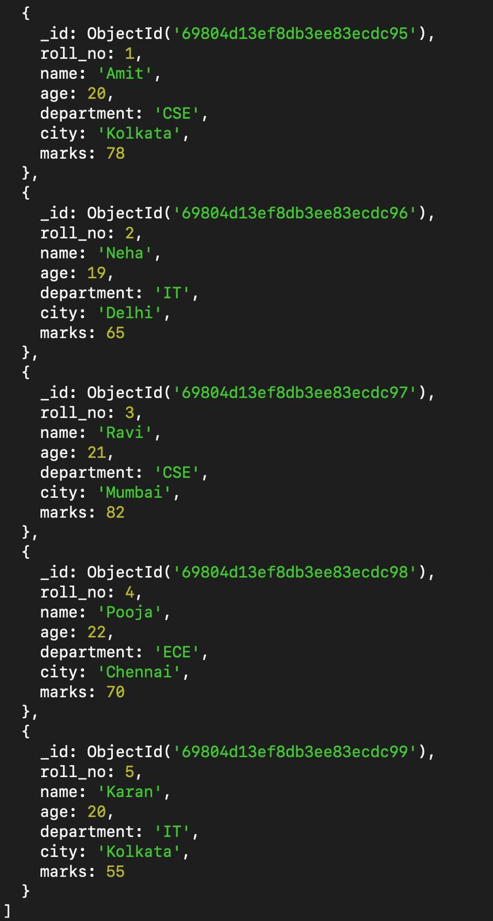

Q2. Display only the name and department of all students.
db.students.find({}, { _id: 0, name: 1, department: 1 })
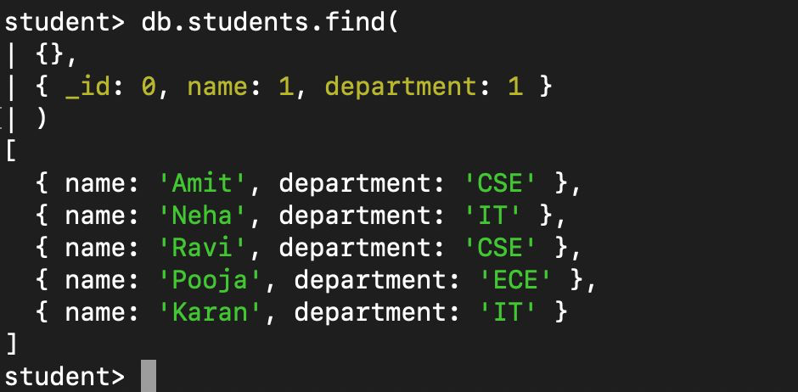

Q3. Find students belonging to the CSE department.
db.students.find({ department: 'CSE' })
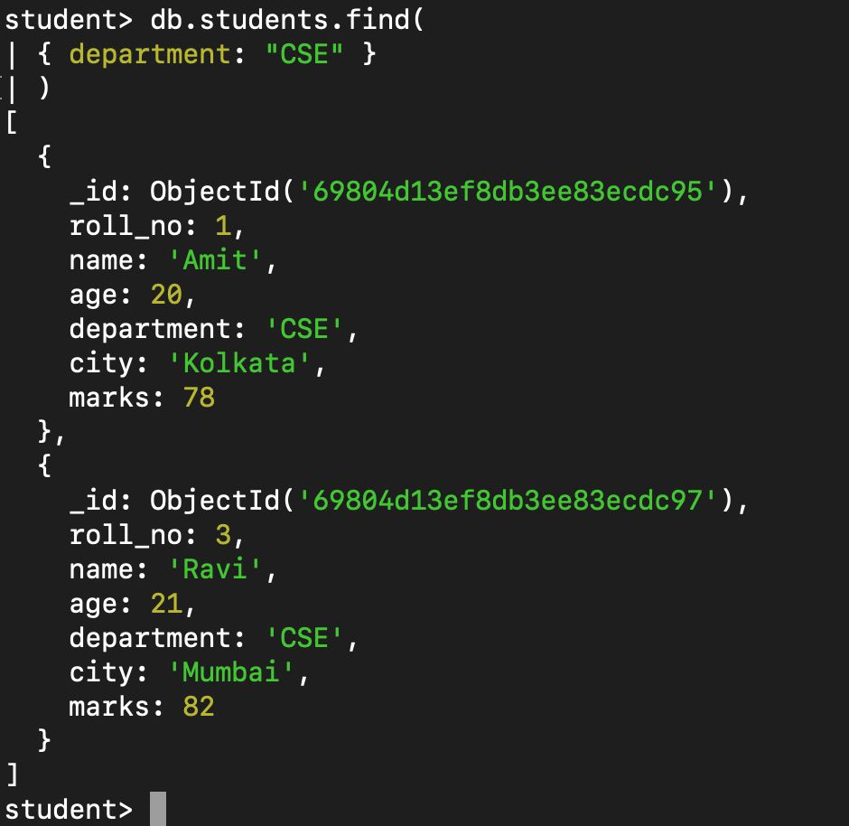

Q4. Find students whose age is greater than 20.
db.students.find({ age: { $gt: 20 } })
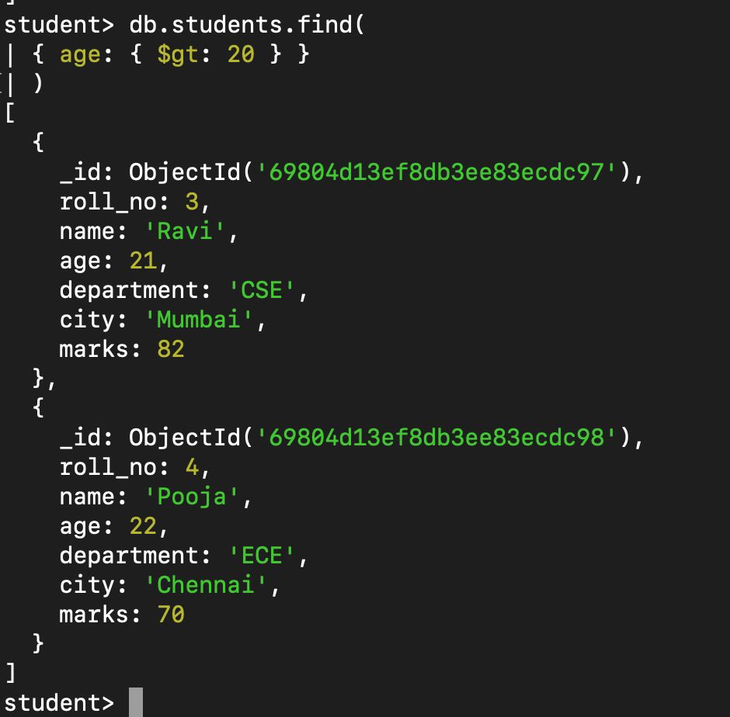

Q5. Find students who scored less than 70 marks.
db.students.find({ marks: { $lt: 70 } })
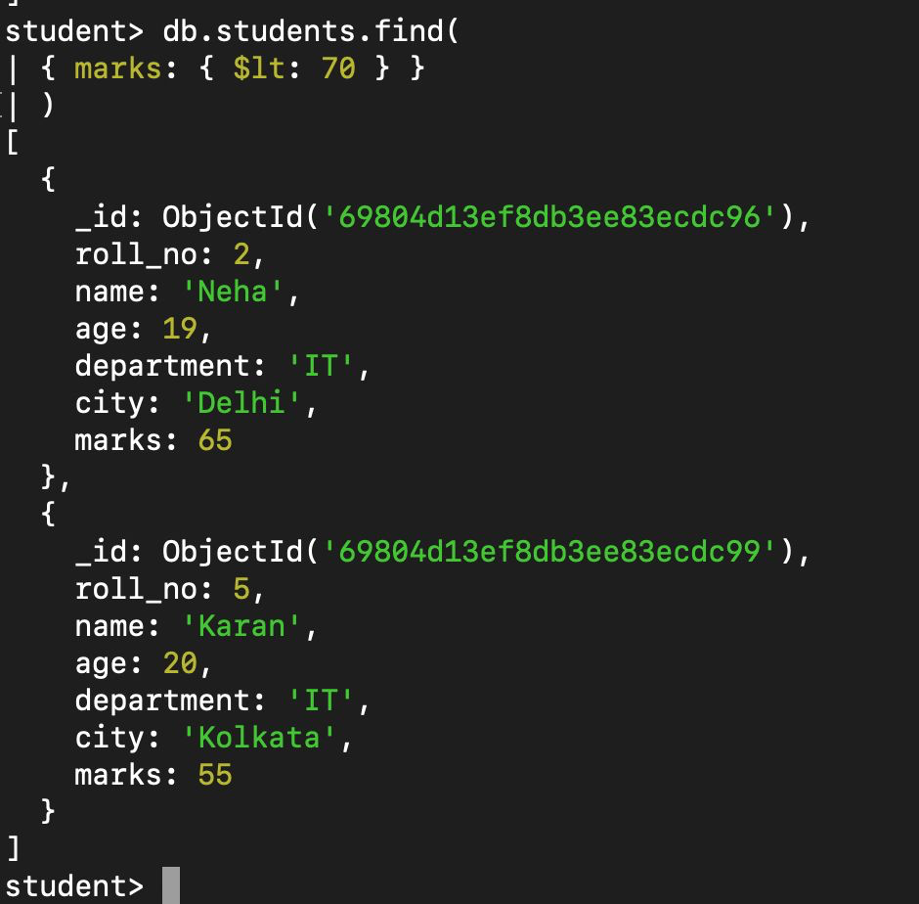

Q6. Display students belonging to Kolkata city.
db.students.find({ city: 'Kolkata' })
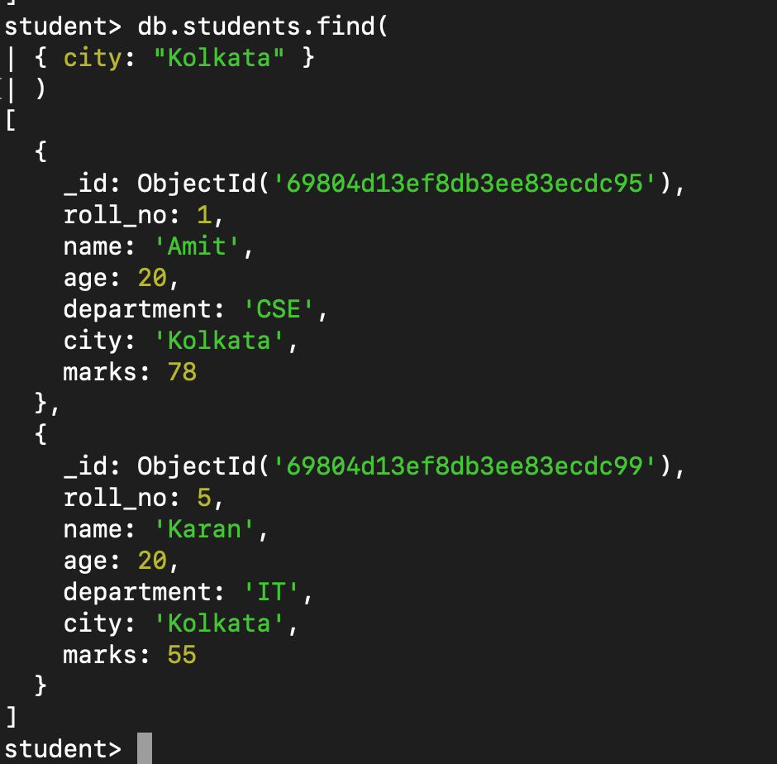

Q7. Sort students by age in ascending order.
db.students.find().sort({ age: 1 })
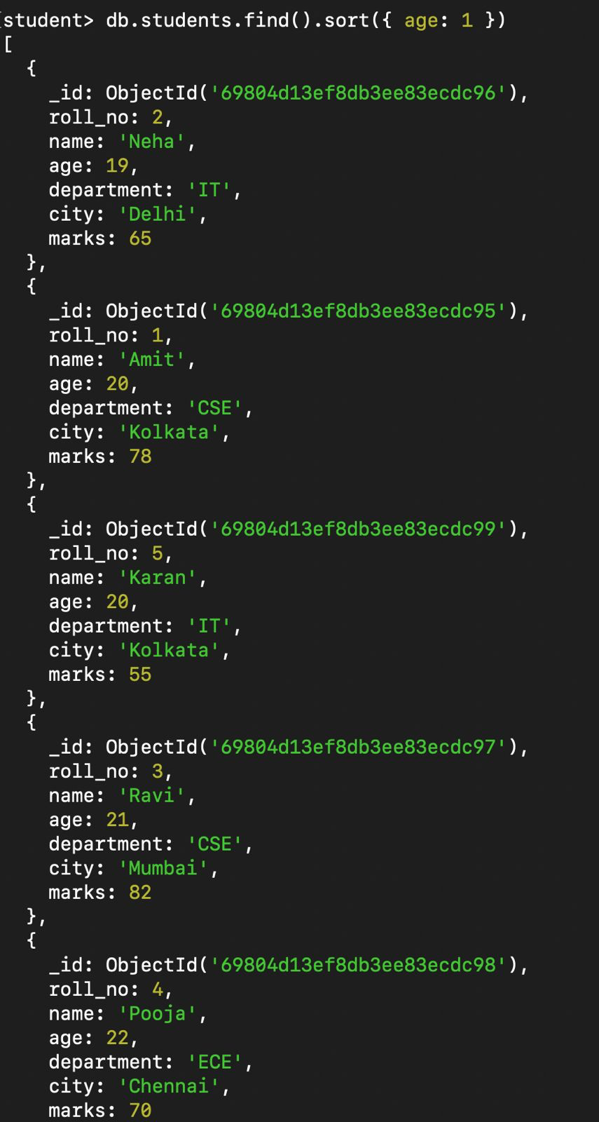

Q8. Sort students by marks in descending order.
db.students.find().sort({ marks: -1 })
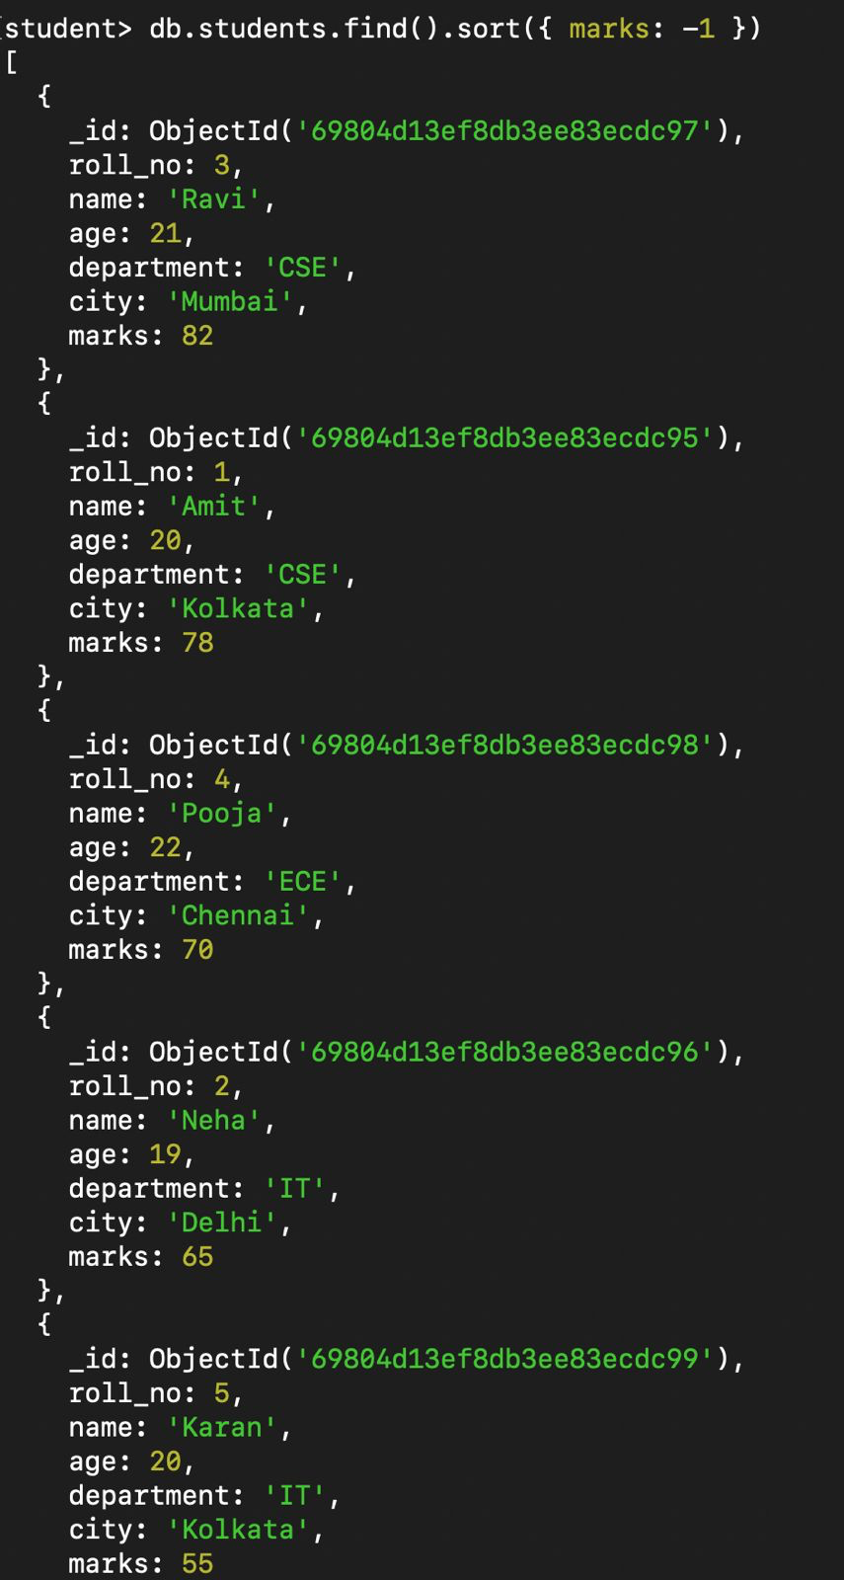

Q9. Display only the first three student records.
db.students.find().limit(3)
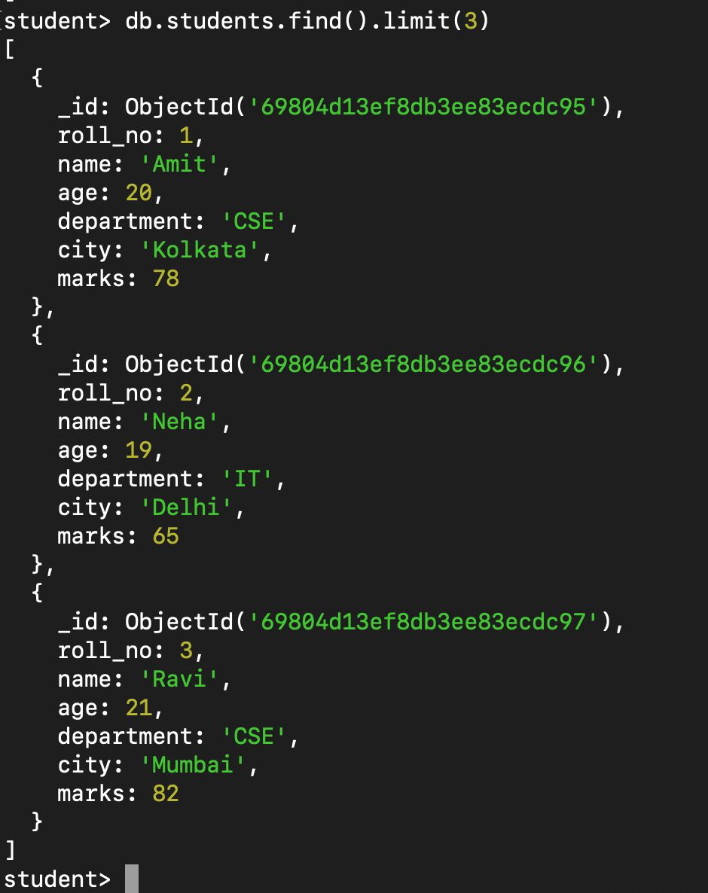

Q10. Update the marks of student Neha to 72.
db.students.updateOne({ name: 'Neha' }, { $set: { marks: 72 } })
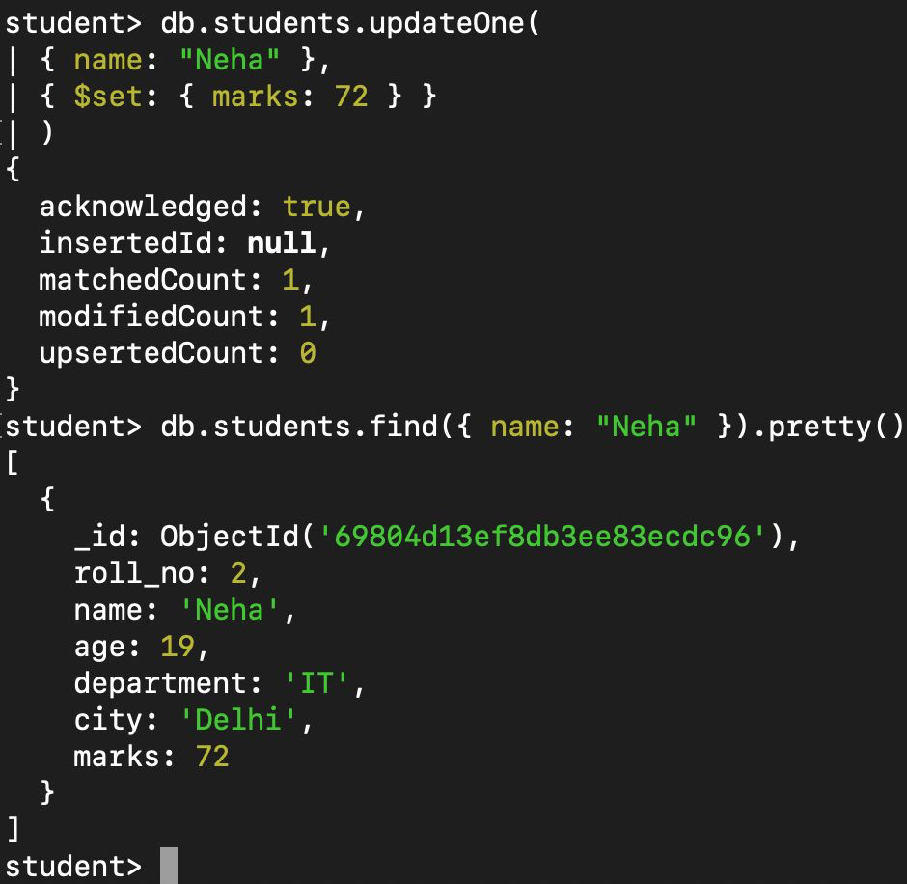

Q11. Increase the marks of all students by 5.
db.students.updateMany({}, { $inc: { marks: 5 } })
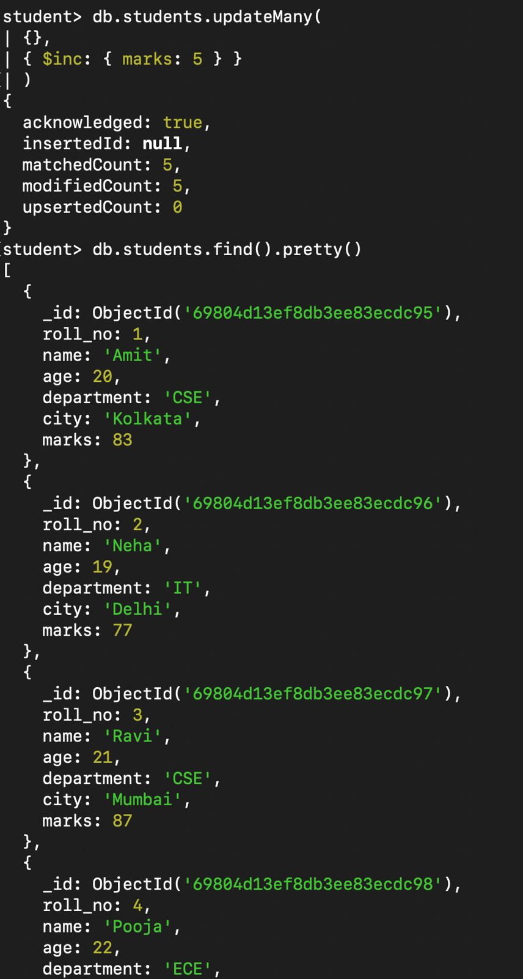

Q12. Delete the student having roll number 5.
db.students.deleteOne({ roll_no: 5 })
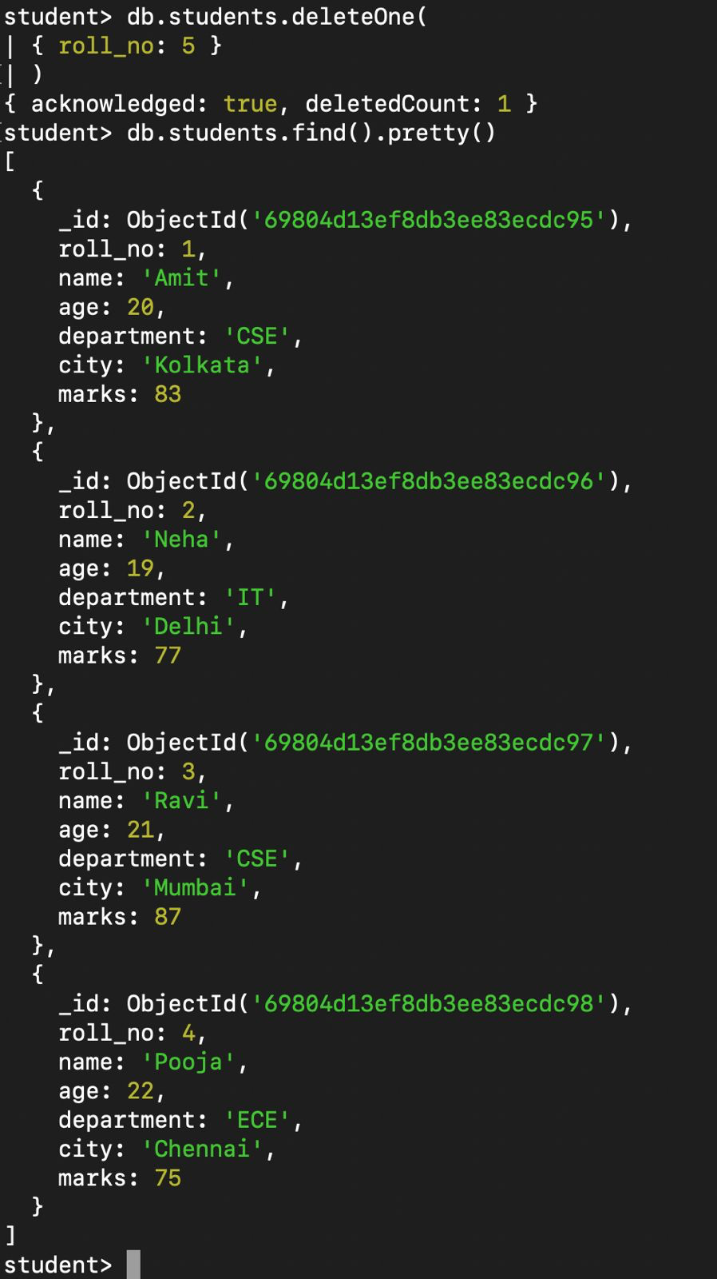

Q13. Find students whose age is between 20 and 22.
db.students.find({ age: { $gte: 20, $lte: 22 } })
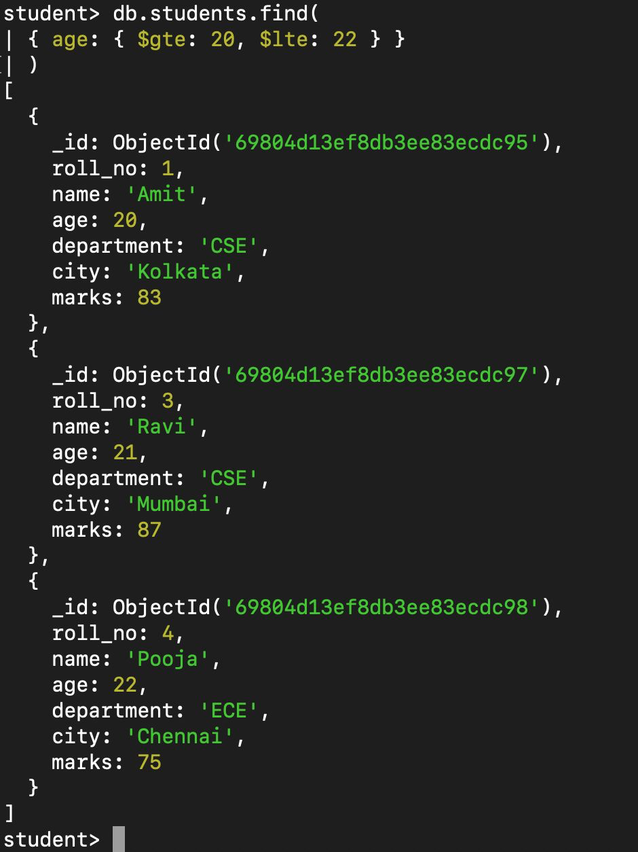

Q14. Display students belonging to either CSE or IT department.
db.students.find({ department: { $in: ['CSE', 'IT'] } })
